Name: ___________________________________ Date: _________________________
Fossils Review
- If a paleontologist finds a fossil of a fish on top of a mountain. She can infer that the area was once UNDERWATER.

- (S3E2.b) Long ago, small organisms became trapped in sticky tree sap that hardened. What is the hardened sap called? AMBER

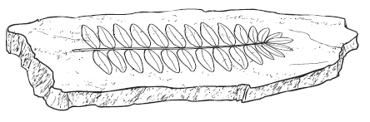
- (S3E2.b) Which MOST LIKELY made this fossil?
A. an animal
B. a bone
C. a footprint
D. A PLANT

- (S3E2.b) Which type of fossil does the picture show?
A. amber
B. a cast
C. AN IMPRINT
D. a mold

- (S3E2.b) When fossilized trees have turned into rock, they are called PETRIFIED.

- (S3E2.b) Which type of fossil is formed when the remains of a plant, animal, or fish are buried in the mud and over time the mud filled in all of the spaces around the shell. The shell then broke down and the mud hardened. Which type of fossil was formed? MOLD

- (S3E2.b) A scientist who studies fossils and organisms that lived long ago is called a PALENTOLOGIST.

- (S3E2.b) Which of the following can a scientist learn from a fossil of a shark’s tooth? HOW LARGE THE SHARK WAS.

- (S3E2.b) How is a cast formed? MINERALS, SAND, OR MUD FILL IN THE SPACES OF A MOLD.

- (S3E2.b) If you found a fossil of a leaf in a rock, you would know that the fossil formed when THE LEAF FELL INTO SOIL THAT LATER BECAME ROCK.

- (S3E2.b) Which object will MOST LIKELY contain a fossil?
A. a leaf
B. an atom
C. A ROCK
D. a mineral

12. (S3E2.b) Fossils are usually found in ROCK.
13. (S3E2.b) Fossils helps us learn about LIFE LONG AGO.
14. (S3E2.b) A fish fossil might form when a fish dies and IT IS PRESSED INTO SOFT ROCK.
15. (S3E2.b) Steven found a fossil of a leaf. How did the leaf become a fossil? A LEAF WAS PRESSED INTO MUD THEN TURNED INTO ROCK.

